Sennheiser and fabric London launch expanded collaboration spanning events, content and fan activations

London, UK, July 2026 – Sennheiser, the globally renowned audio specialist behind some of the world's most trusted consumer and professional audio solutions, today announced an expanded collaboration with fabric London, one of the world's most influential electronic music institutions.

Bringing together two organisations united by a commitment to exceptional sound, technical innovation and music culture, the partnership will include live events, consumer activations and audio storytelling designed to explore the technologies, expertise and creative processes behind exceptional sound clubs, live shows and personal listening.

As part of the partnership, Sennheiser will host a series of exclusive events with fabric at The View from The Shard, offering the opportunity to experience world-class electronic music in one of London's most iconic venues. The first of these will kick off on 21 August with a special performance from electronic music pioneer Sven Väth, with further events taking place throughout the year.

The collaboration also extends to music fans, with fabric followers able to enter exclusive competitions to win a bespoke fabric Edition of Sennheiser's new flagship MOMENTUM 5 Wireless headphones. The brand's latest five-star-rated over-ear launch, the MOMENTUM 5 brings Sennheiser's signature sound from the club environment into everyday listening.
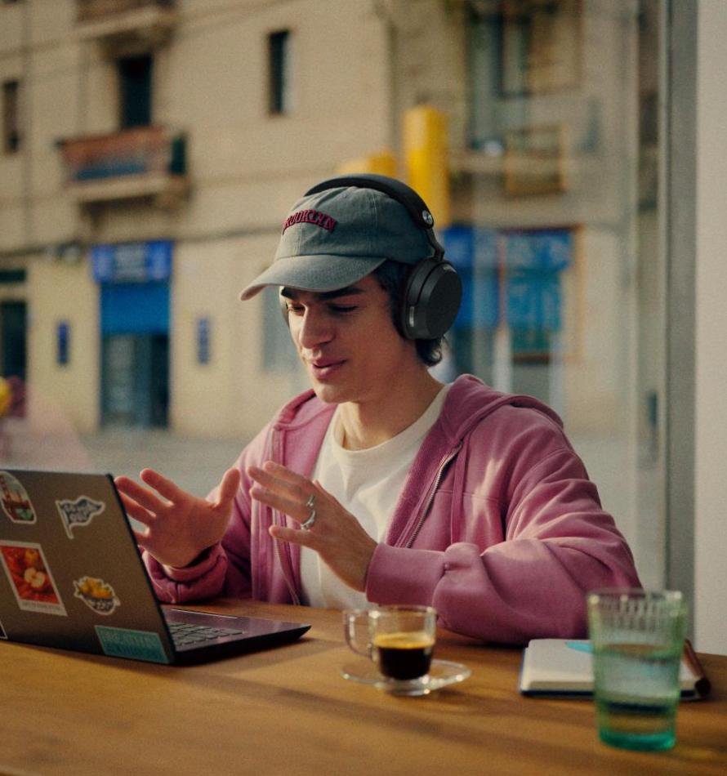
Sennheiser Momentum 5

Working alongside fabric's renowned sound and production teams, Sennheiser will develop content designed to provide long-term educational value, offering insight into the expertise, decision-making and technologies behind world-class audio experiences.

The partnership will also showcase the real-world application of professional audio technology through collaborations with artists and creative communities, including Orii Community, which supports emerging and underrepresented talent. These collaborations will give audiences insight into how Sennheiser gear is used in live performance settings, including digital wireless microphone solutions such as EW-DX, to help artists, engineers and production teams deliver high-quality audio in demanding environments.
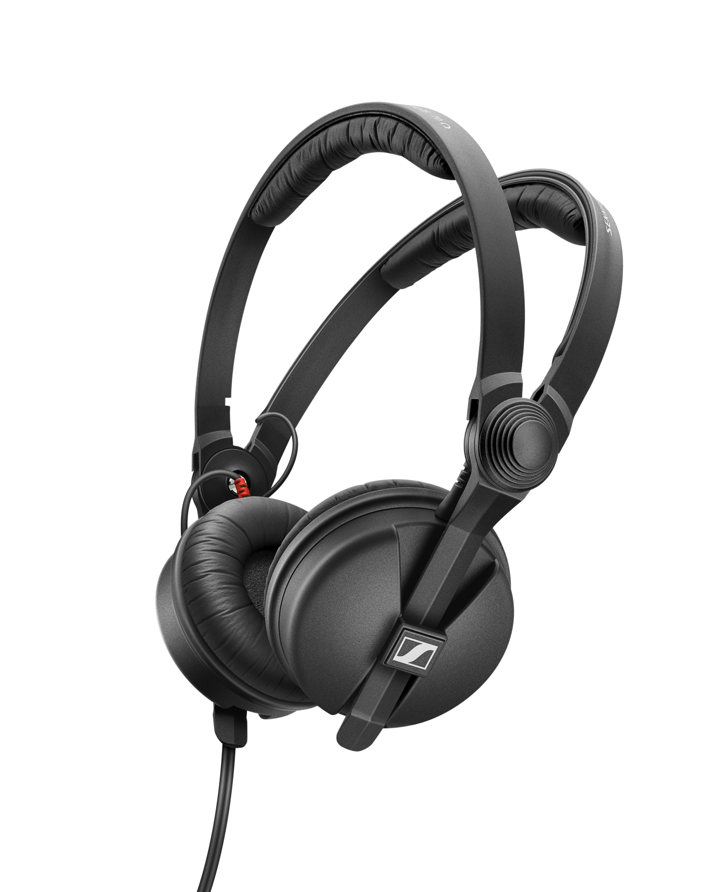

Sennheiser's iconic HD 25 headphones will be a key feature throughout the partnership. For more than three decades, the HD 25 have been a trusted tool within DJ booths, broadcast environments and professional monitoring systems around the world. The audience will get a closer look at the enduring role these professional headphones play in contemporary DJ, on-location broadcast, and film monitoring.

“The collaboration with fabric reflects how we approach brand partnerships at Sennheiser: Connecting culture, technology and community to create authentic experiences around sound”, says Andreas Andersson, Regional Marketing Manager at Sonova Consumer Audio UK.
Itamar Marom, Brand Partnership Manager at Sennheiser, continues: “By combining technical storytelling with live performances, we’re making our brand more tangible while strengthening our relevance with the next generation of music professionals”.

"This partnership is about much more than technology” says Jacob Hansen, Senior Progamming Lead at fabric. “It's about bringing together Sennheiser's expertise across both professional audio and personal listening to create experiences where exceptional sound becomes part of the storytelling. Together, we are opening exciting new spaces for electronic music, giving artists and audiences new ways to connect while celebrating the craft behind great sound."

By bringing together Sennheiser's expertise across both consumer and professional audio with fabric's reputation as one of the world's leading electronic music institutions, this partnership creates new exciting opportunities to celebrate the people, technologies and creative processes behind exceptional sound.

ENDS

About the Sennheiser Brand – More than 80 Years of Building the Future of Audio
We live and breathe audio. We are driven by the passion to create audio solutions that make a difference. This passion has taken us from the world’s greatest stages to the quietest listening rooms – and made Sennheiser the name behind audio that doesn’t just sound good: It feels true. Since 1945, we have stood for building the future of audio and bringing remarkable sound experiences to our customers.

While professional audio solutions such as microphones, meeting solutions, streaming technologies and monitoring systems are part of the business of Sennheiser electronic SE & Co. KG, the business with consumer devices such as headphones, soundbars and speech-enhanced hearables is operated by Sonova Holding AG under the license of Sennheiser.

About Sonova Consumer Hearing
Sonova Consumer Hearing offers premium headphones and hearables – primarily in the true wireless segment – as well as audiophile headphones, hearing solutions and soundbars under the Sennheiser brand. The business is part of the Sonova Group, a global leader in innovative hearing care solutions with headquarters in Switzerland and more than 17,000 employees worldwide.

sennheiser.com
uk.sennheiser-hearing.com

About fabric
Since opening its doors in 1999, fabric has remained at the forefront of club culture and electronic music. Consistently platforming a diverse range of genres, artists and communities, the London institution has played a pivotal role in shaping the global dance music landscape for over 27 years. Today, fabric is recognised as a leading authority on cutting-edge electronic music experiences, spanning its programme of events at its home venue in London, its international world tour, and the label family that sits under the fabric umbrella, including fabric Records, Houndstooth, Originals and FABRICLIVE.

Press contact
Piston Agency
SennheiserUK@pistonagency.com

